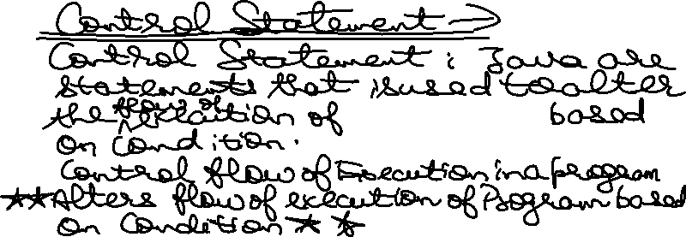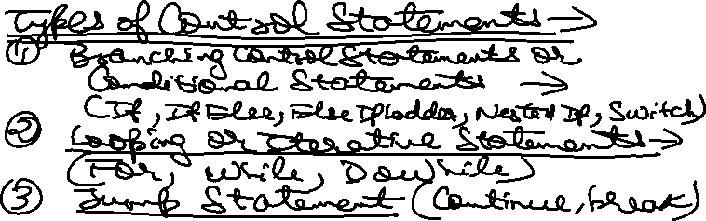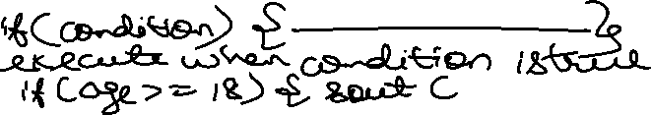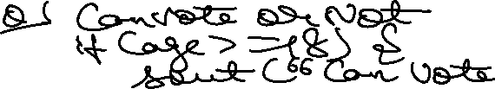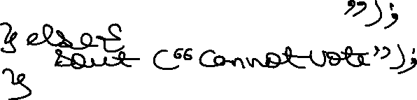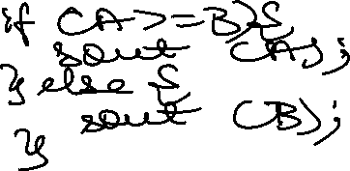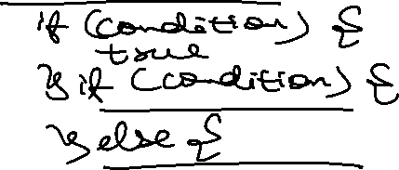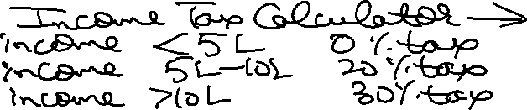

import java.util.Scanner;

class IncomeTax {

    public static void main(String[] args) {

        Scanner sc = new Scanner(System.in);

        System.out.println("Enter your Income = ");

        int income = sc.nextInt();

        int tax = 0;

        if(income<500000){

            tax = 0;

        }else if(income>=500000 && income < 1000000){

            tax = (int)(income\*0.2);

        }else if(income>=1000000){

            tax = (int)(income\*0.3);

        }else{

            System.out.println("Enter Correct Income Details!");

        }

        System.out.println("Tax is = "+tax+" for Income = "+income);

        sc.close();

    }

}



import java.util.Scanner;

class Largestof3 {

    public static void main(String[] args) {

        // input part

        Scanner sc = new Scanner(System.in);

        int n1, n2, n3;

        System.out.println("Enter Value of n1 = ");

        n1 = sc.nextInt();

        System.out.println("Enter Value of n2 = ");

        n2 = sc.nextInt();

        System.out.println("Enter Value of n3 = ");

        n3 = sc.nextInt();

        // conditional statements part

        if(n1>n2){

            if(n1>n3){

                System.out.println("n1 is the Greatest or Largest = n1 = "+n1);

            }

            else{

                System.out.println("n3 is the Greatest or Largest = n3 = "+n3);

            }

        }else{

            if(n2>n3){

                System.out.println("n2 is the Greatest or Largest = n2 = "+n2);

            }

            else{

                System.out.println("n3 is the Greatest or Largest = n3 = "+n3);

            }

        }

        sc.close();

    }

}



import java.util.Scanner;

class Largestof3Alt {

    public static void main(String[] args) {

        // input part

        Scanner sc = new Scanner(System.in);

        int n1, n2, n3;

        System.out.println("Enter Value of n1 = ");

        n1 = sc.nextInt();

        System.out.println("Enter Value of n2 = ");

        n2 = sc.nextInt();

        System.out.println("Enter Value of n3 = ");

        n3 = sc.nextInt();

        // conditional statements part

        if((n1 >= n2) && (n1 >= n3)){

            System.out.println("n1 is the Greatest or Largest = n1 = "+n1);

        }else if (n2 >= n3) {

            System.out.println("n2 is the Greatest or Largest = n2 = "+n2);

        }else{

            System.out.println("n3 is the Greatest or Largest = n3 = "+n3);

        }

        sc.close();

    }

}

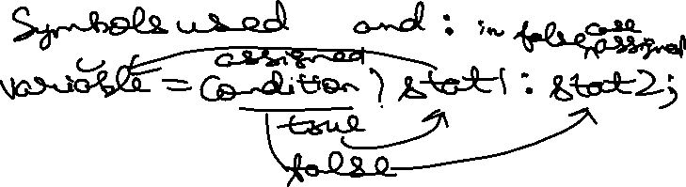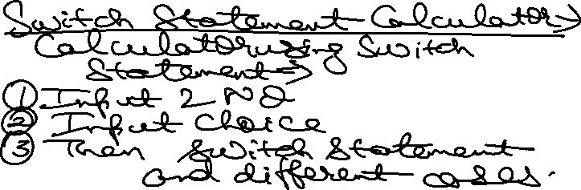

import java.util.Scanner;

class CalculatorusingSwitch {

    public static void main(String[] args) {

        Scanner input = new Scanner(System.in);

        // Input 2 No.

        System.out.println("Enter the Value of Number 1 = ");

        int Number1 = input.nextInt();

        System.out.println("Enter the Value of Number 2 = ");

        int Number2 = input.nextInt();

        // Input Choice

        System.out.println("Enter your Choice = ");

        System.out.print("1 for Addition \n2 for Subtraction \n3 for Multiplication \n4 for Division \n5 for Modulous(Remainder) = ");

        int Choice = input.nextInt();

        // Switch Statement

        switch (Choice) {

            case 1:

                System.out.println("Addition of Two Numbers is = "+(Number1+Number2));

                break;

            case 2:

                System.out.println("Subtraction of Two Numbers is = "+(Number1-Number2));

                break;

            case 3:

                System.out.println("Multiplication of Two Numbers is = "+(Number1\*Number2));

                break;

            case 4:

                System.out.println("Division of Two Numbers is = "+(Number1/Number2));

                break;

            case 5:

                System.out.println("Modulous(Remainder) of Two Numbers is = "+(Number1%Number2));

                break;

            default:

                System.out.println("Enter Choice from 1 to 5 Only!");

                break;

        }

        input.close();

    }

}

import java.util.Scanner;

class CalculatorSwitch {

    public static void main(String[] args) {

        Scanner input = new Scanner(System.in);

        // Input 2 No.

        System.out.println("Enter the Value of Number 1 = ");

        int Number1 = input.nextInt();

        System.out.println("Enter the Value of Number 2 = ");

        int Number2 = input.nextInt();

        // Input Choice

        System.out.println("Choice you can enter is +, -, \*, /, % for Operations.");

        System.out.print("Enter your Choice = ");

        char Choice = input.next().charAt(0);

        // Switch Statement

        switch (Choice) {

            case '+':

                System.out.println("Addition of Two Numbers is = "+(Number1+Number2));

                break;

            case '-':

                System.out.println("Subtraction of Two Numbers is = "+(Number1-Number2));

                break;

            case '\*':

                System.out.println("Multiplication of Two Numbers is = "+(Number1\*Number2));

                break;

            case '/':

                System.out.println("Division of Two Numbers is = "+(Number1/Number2));

                break;

            case '%':

                System.out.println("Modulous(Remainder) of Two Numbers is = "+(Number1%Number2));

                break;

            default:

                System.out.println("Enter Correct Symbol!");

                break;

        }

        input.close();

    }

}